Tec/5 William Copeland
18th Infantry Regiment, 1st Infantry Division
Omaha Beach

1920 Census

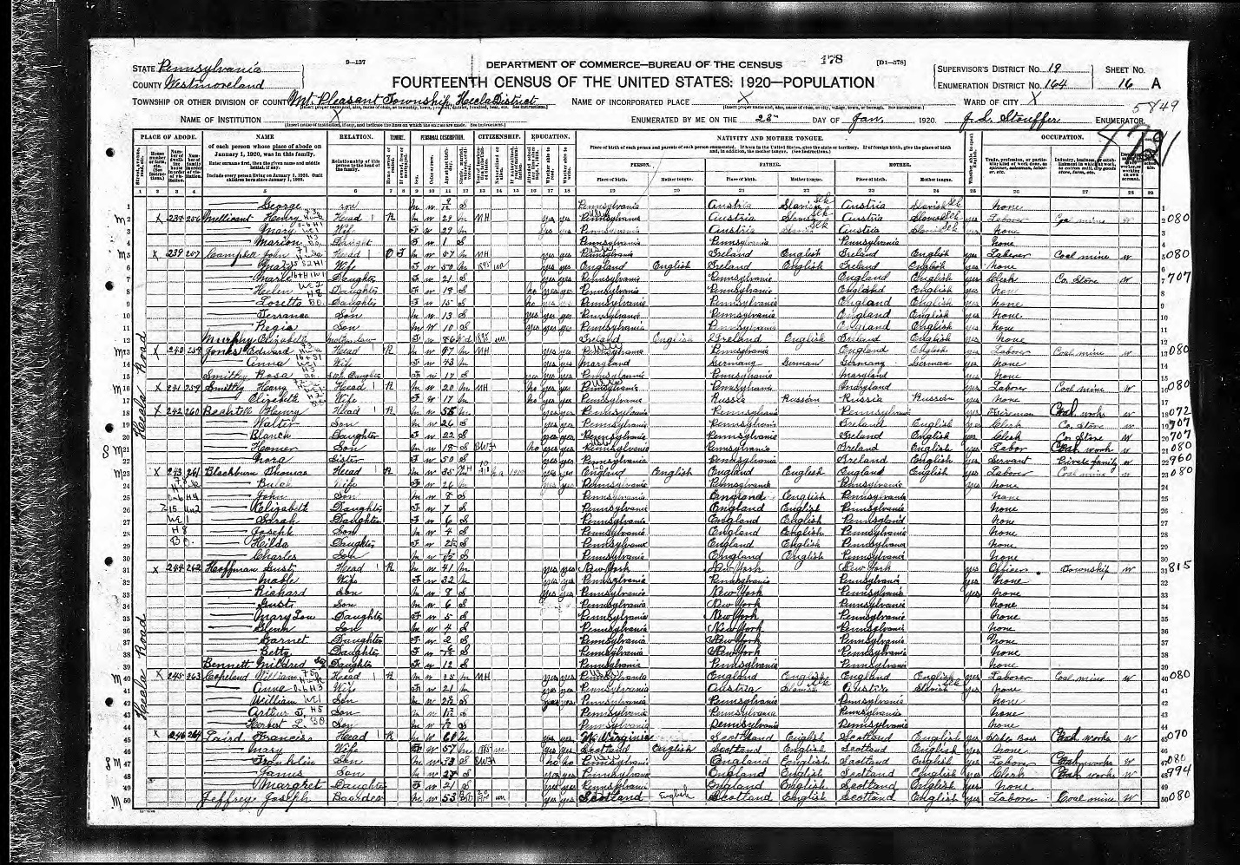

1930 Census
Westmoreland County Childrens and Youth Home
(William is listed at the bottom of the page)
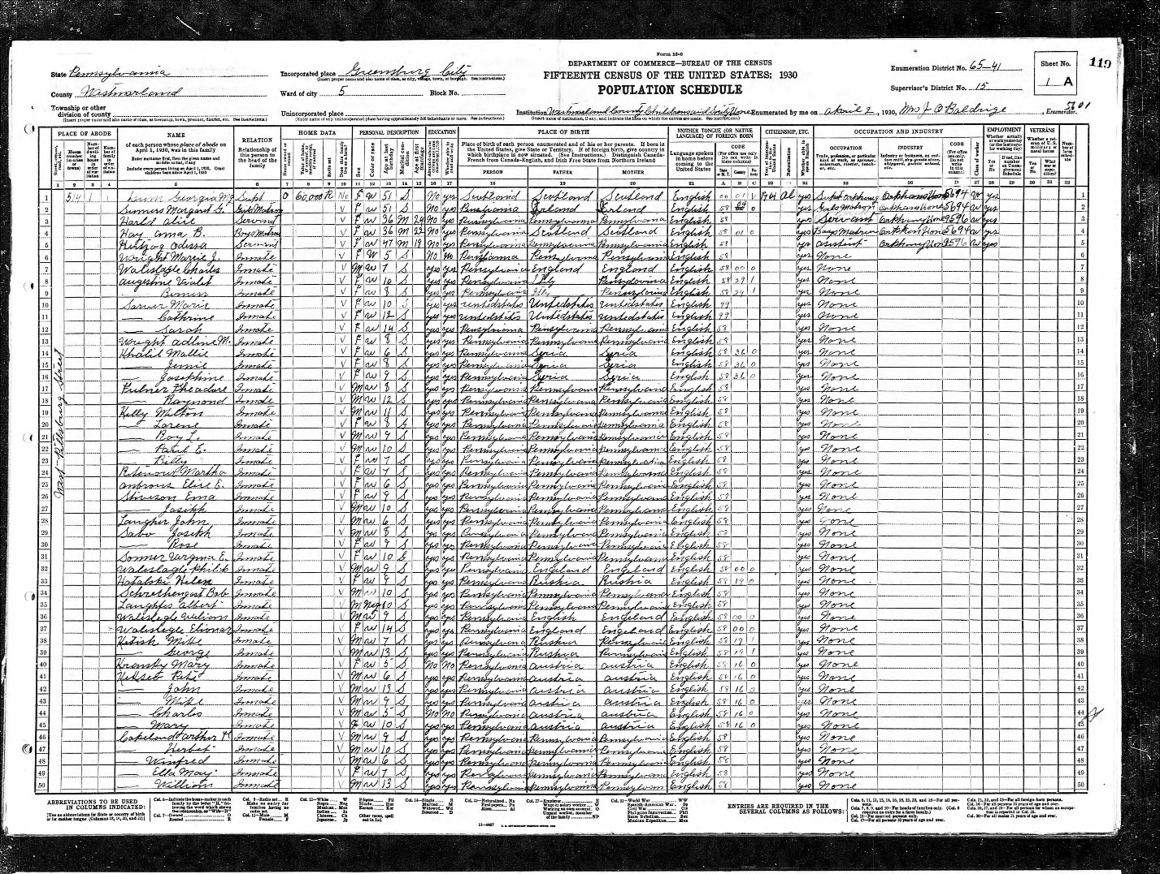

Pension File
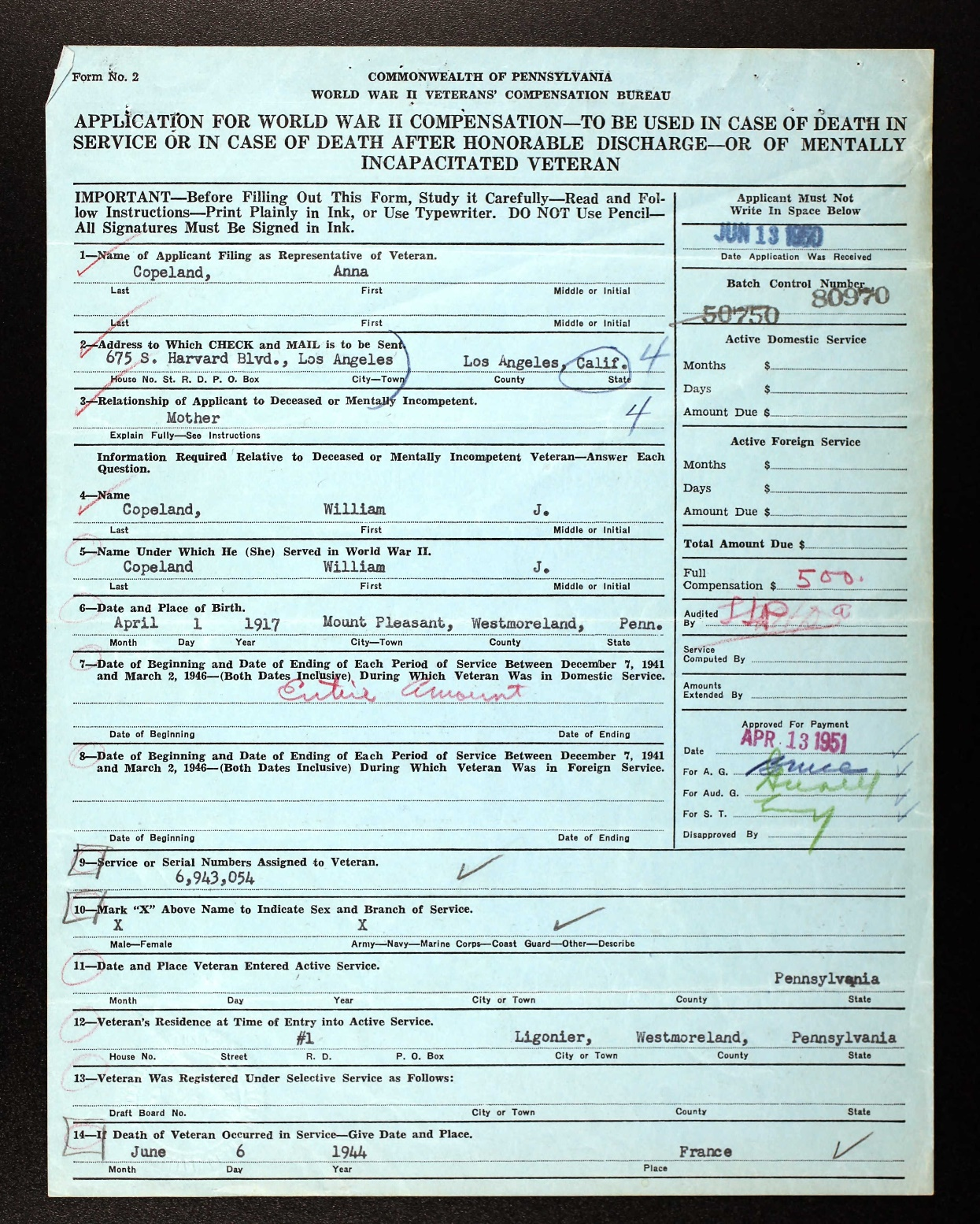
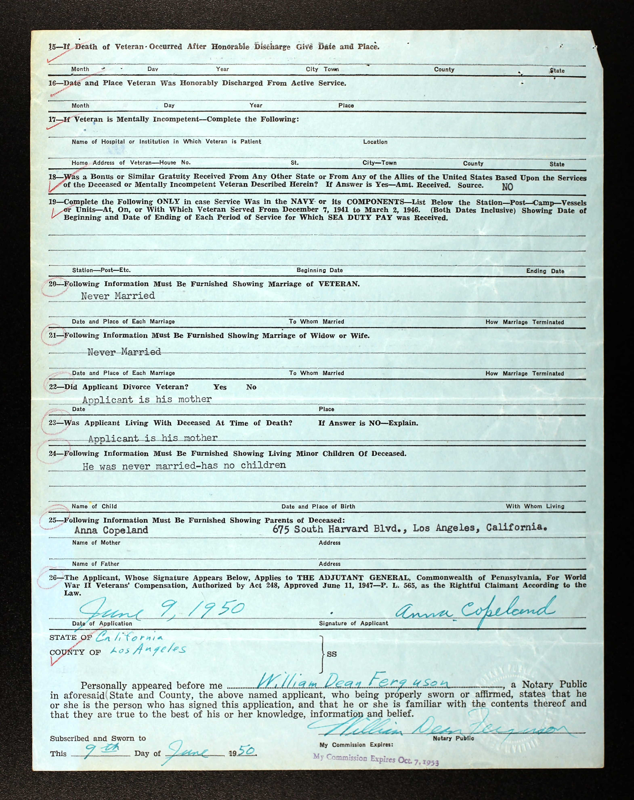

National Cemetery Interment Form
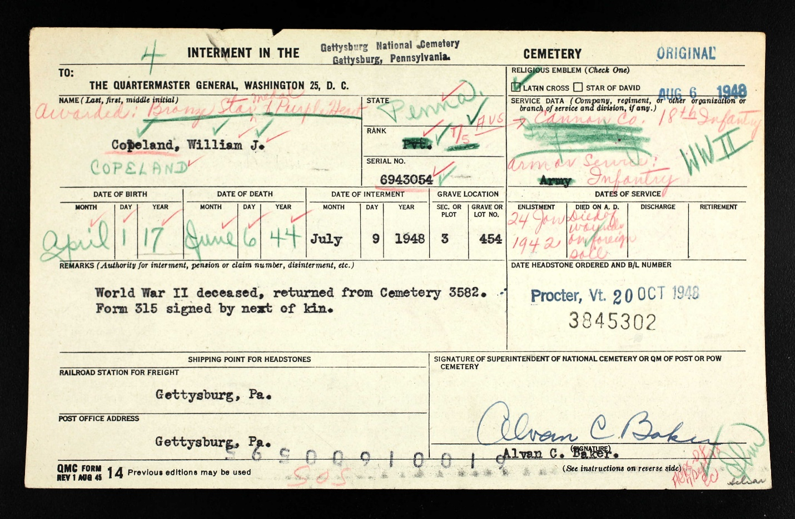

Latrobe Bulletin, Latrobe, PA, July 24, 1944
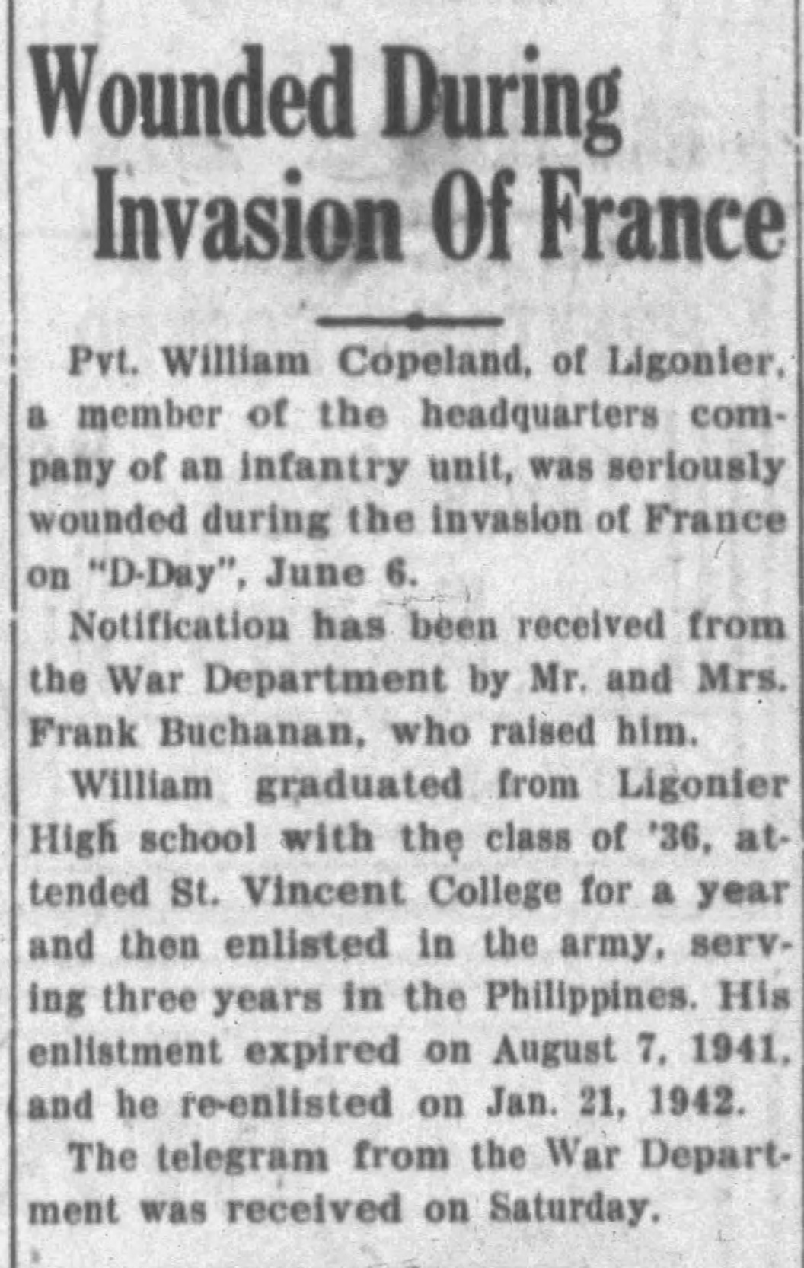

The Ligonier Echo, Ligonier, PA, September 8, 1944
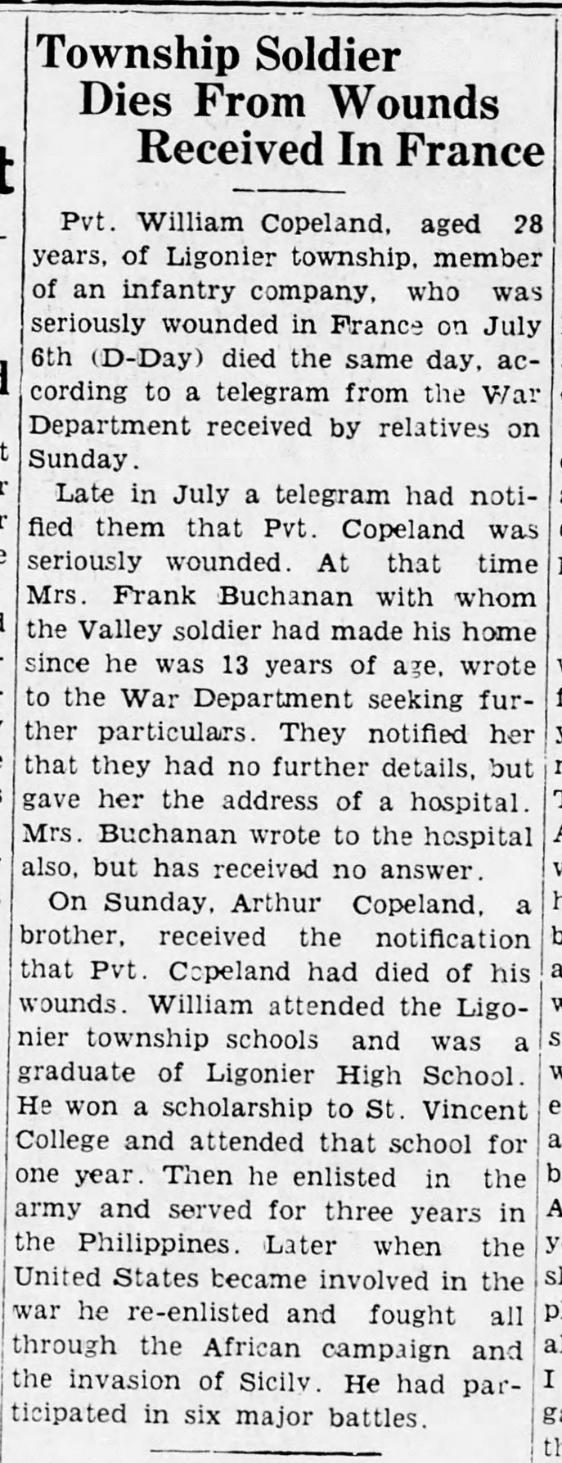
US Army Press Release Records for Bronze Star,
1942-1945
